St. George Byzantine Catholic Church
“There is no greater calling than the education of our youth in the faith.” ~ St. John Chrysostom
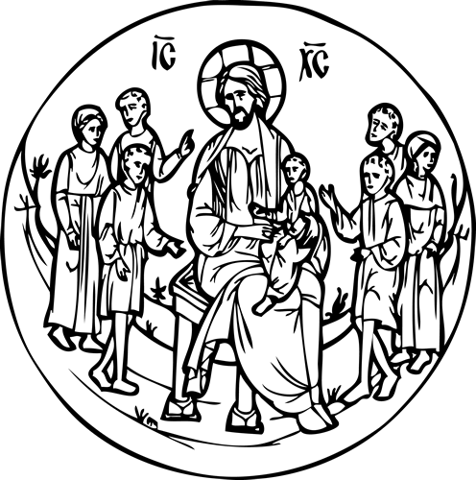
2018-2019 ECF Registration
(Eastern Christian Formation)
1001 Clinton Street
Aliquippa, PA 15001
724-375-2742

Child’s Name____________________________________ Birth Date______________________
Address_______________________________________________________________________
______________________________________________________________________________
Home Phone____________________________ Cell Phone______________________________
Email (for communication purposes) ________________________________________________
Parent’s/Guardian Name(s) _______________________________________________________

The ECF program exists as a result of your support through your child’s enrollment and attendance and as a result of many gifts such as volunteering of time and supplies. Please check the gifts you are able to offer:

- I would like information on becoming a catechist (no obligation)

- I would like to volunteer in the ECF classrooms, for craft projects, etc., as needed

- I would like to help with organizing, cleaning, or set up of ECF classrooms

- I have items to donate; ex. shelving, small tables/furniture, rugs, construction paper, etc.

- I wish to make a monetary donation

Any suggestions below:

